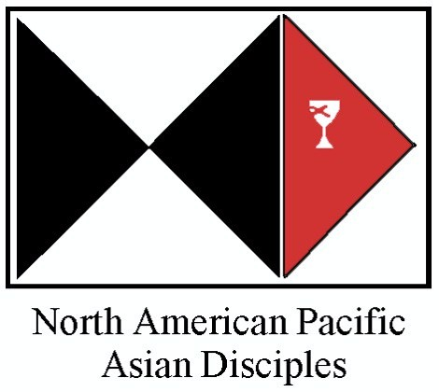
The Geunhee Yu Covenant Fund
Grant Application
Application Deadline: October 31, each year
for following year.

Origin of the Fund

This fund was set up in 2012 at the seventeenth biennial NAPAD Convocation, to perpetuate the legacy of Rev. Dr. Geunhee Yu, who served as the Inaugural Executive Pastor of NAPAD from 1992 until his retirement in 2011. Rev. Dr. Yu has inspired us with his tireless servant leadership, deep commitment to a covenant of love and justice, and an unsurpassed passion for new church development.

Purpose of Grants

The fund aims to provide grants to new churches that have great potential to become strong NAPAD congregations. The grants go directly to selected congregations. The grants may not be used for pastors’ salary. They must be used to accomplish the vision and mission of the awardee congregation(s). There may be one or more grants each year, and each grant’s value will range between $2,500 and $6,000. Each grant will be distributed quarterly upon the receipt of a quarterly progress report from the awardee congregation.

Eligibility for Application

Congregations must meet the following eligibility requirements in order to apply for the Geunhee Yu Covenant Fund.

1. Congregations must be recognized by the Executive Pastor of NAPAD as NAPAD affiliates.
2. Congregations must be under care with the Disciples of Christ Region it is located in.
3. Congregations must have been placed under care of the Region less than 5 years
before the deadline of application.
4. The minister of the congregation must be under care and/or in good standing with its region.

Geunhee Yu Covenant Fund
Grant Application Form
Application Deadline: October 31, each year for following year

APPLICATION INFORMATION

Date:

Congregation Name:

Address City State Zip Code

Phone number Fax number E-mail

Applying Person(s) Name Position

Address Phone E-mail

Name of Region:

Date when the church was placed under the Region’s care:

Average Number of Attendees for Sunday Worship:

Any previous financial support from Region or NAPAD: ( ) Yes ( ) No
(If yes, from when to )

Participation in events and programs of NAPAD, Region, and General Church: ( ) Yes ( ) No
If yes, please indicate what they are.

PROPOSAL INFORMATION

Name of Proposal:

Proposal Amount Requested: $ Total Cost of Funding Objective(s): $

Beginning and Ending Dates of Funding Objective(s):

* Summary of Proposal (200-word maximum):

* Aims, Purposes and Rationale of Proposal:

* Target Audience(s):

* Outcome Assessment(s)/Measurement(s):

* Proposal Budget for the grant (expenses/income):

* Please use a separate sheet for these items and send them in with the application form.

OTHER MATERIALS

Church’s financial statement for current year:

Strategic plan to reach the goal using the fund:

Endorsement letter by the Regional Minister or recommendation or NAPAD ministry staff:

Please Note:

- All grant applicants must completely fill out each section of the proposal. All application materials must reach the NAPAD office by the deadline, October 31, each year for following year.

- The Geunhee Yu Covenant Fund Committee will award grants to applications that best meet the stated criteria.

- The NAPAD office will respond in writing to all grant applicants by December 15, each year.

- All applications must be completed in English. If you need assistance with translations, please contact the NAPAD Office (ckim@napad.disciples.org).

- All application packages must be limited to 8 pages or less. Only the applications that meet the stated requirements will be considered.

APPLICATION MATERIALS MUST BE SENT
TO THE FOLLOWING ADDRESS

North American Pacific/Asian Disciples
PO BOX 1986
Indianapolis, IN 46206
or
ckim@napad.disciples.org

By Oct 31th, each year for following year

